**Power BI Instruction**

Load Data

1. Make sure you are connected to VPN
2. Open Power BI Desktop
3. Go to the bar above 🡪 Click on “SQL Server”
4. 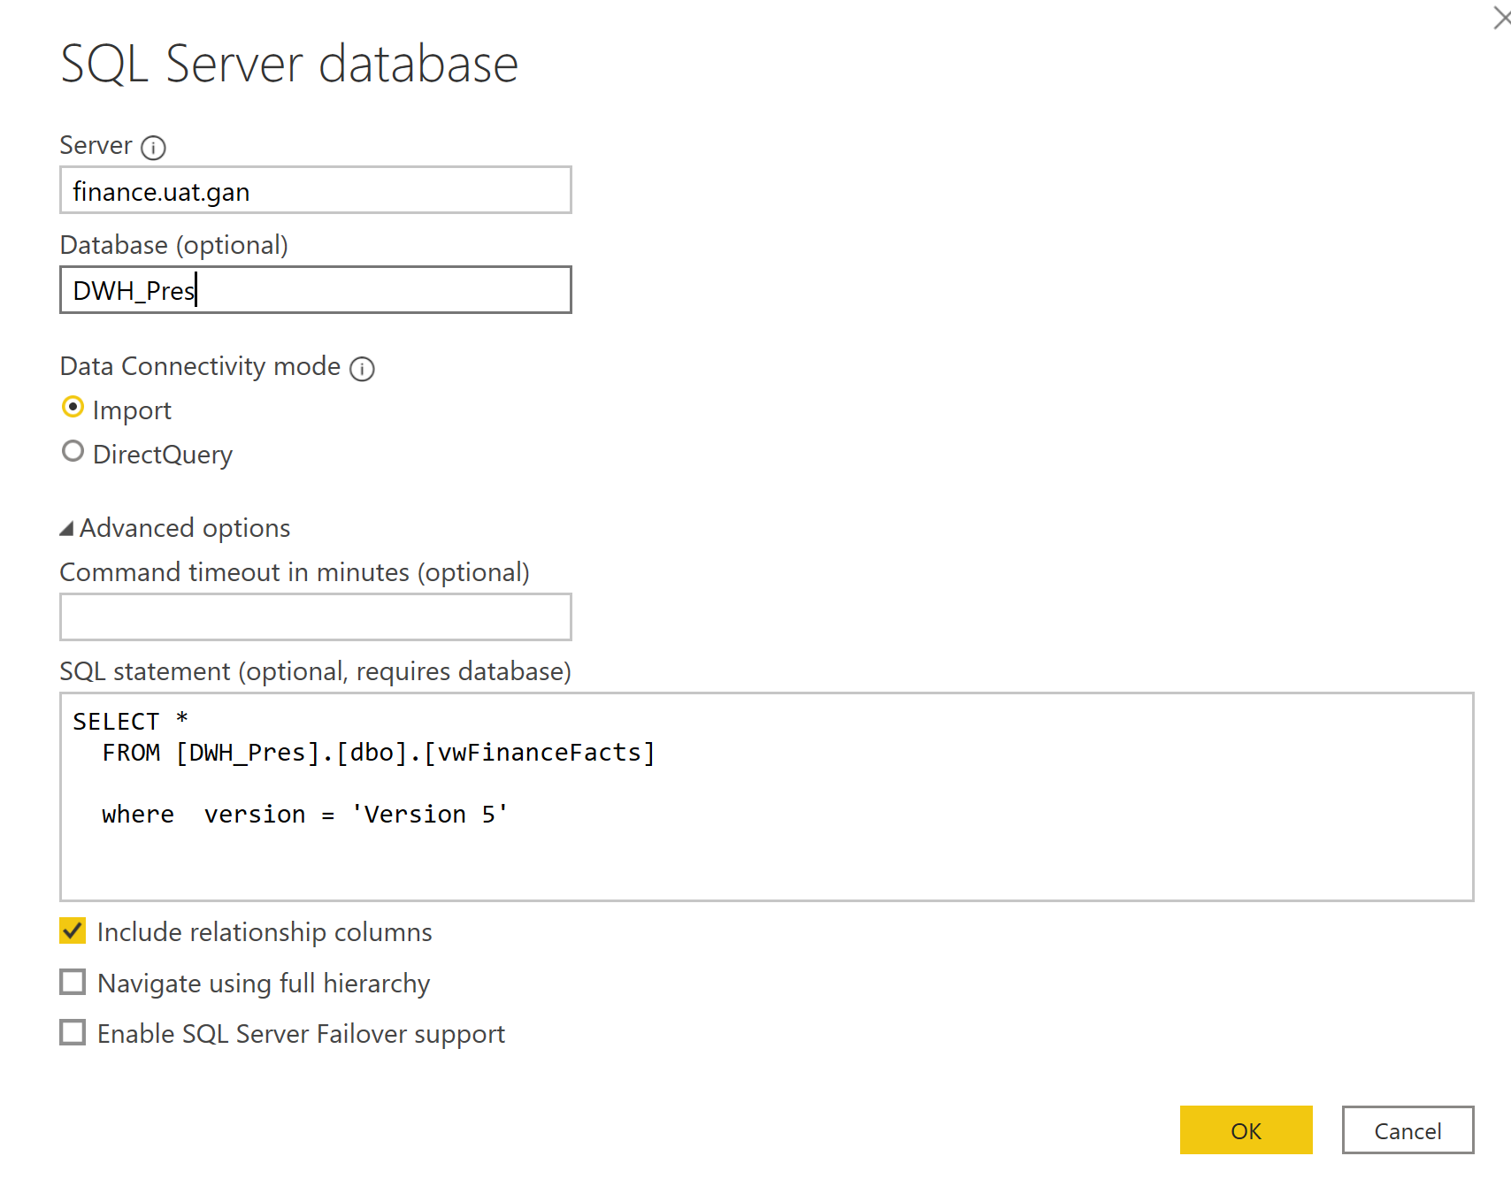

If you want to select whole data base you could just ignore the SQL statement.

Once you click ok, it will require your User ID and Password to the Database to load the data.

**Tip** – you will only need to load the data one time, when you want to update the data just click “Refresh”, it will reload the data for you.

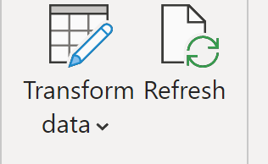

Time Intelligent function:

Comparison:

|  |  |  |
| --- | --- | --- |
| Time Function | Status | Features |
| DATEADD | Dynamic | 1. Period flexible (Year, Quarter, Month, Day) 2. Interval flexible(±1,2,3…) |
| Previousyear(quarter/month/day) | Static | 1. return all dates from the previous period |
| SamePeriodLastYear | Dynamic | 1.return the same period but last year(quarter/month) based on the X axis |
| ParallelPeriod | Static | 1. Interval flexible 2. Period not included Day. |

Tips:

1. Time Intelligent function is very sensitive to the Date table you choose. When you try to visualize your time intelligent function, the X axis you choose should match with the Date you used in your time intelligent function.
2. The more specific time information you want to use, the more complex date table you need to created. Please reference the [Calendar table]

General Tip:

* It could not copy the whole page to different file but you could copy the visuals to different file.
* Slicer could be single/multiple select. You could also filter on this page or whole page
* Slicer could Sync or not in the view
* Value setting
* Sort Value
* Customer Order should create a new table with your custom order then create a new column in your fact data table related to the custom order table.
* The value of a calculated column is computed during data refresh and uses the current row as a context; it does not depend on user interaction in the report.
* A measure operates on aggregations of data defined by the current context, which depends on the filter applied in the report – such as slicer, rows, and columns selection in a pivot table, or axes and filters applied to a chart.
* How to move value to different tables 